NB-532-3-B
Narrow bandpass filter, 532 nm, 3.0 nm FWHM, 25.0 mm mounted
Sespe Optics
Thin-film filters and precision optics
Datasheet NB-DS-532-3-B, Rev B, 2026-10-24. Replaces Rev A of 2026-06-12.
The NB-532-3-B passes a 3.0 nm band centered on 532 nm and blocks 400 to 1100 nm outside CWL ± 12 nm to at least OD 5. It is a three-cavity, ion-beam-sputtered, all-dielectric coating on a UV fused silica substrate, with a broadband antireflection coating on the rear face, mounted in a black anodized aluminum ring. The blocking is reflective: there is no laminated absorbing glass in the stack. Center wavelength, bandwidth and peak transmission are measured on every filter.
Center wavelength | Bandwidth (FWHM) | Peak transmission | Blocking
532 nm | 3.0 nm typ | 85 % min | OD 5 min
531 to 533 nm at AOI 0°, 23 °C | 2.6 to 3.4 nm at AOI 0°, 23 °C | 90 % typical, at the measured CWL, AOI 0° | 400 to 1100 nm, outside CWL ± 12 nm; OD 6 typical

Features
- Center wavelength 532.0 nm, ±1.0 nm at AOI 0°, 23 °C
- Flat-top passband, 3.0 nm FWHM typical
- Peak transmission 90 % typical at the center wavelength, AOI 0°
- Blocking OD 5 minimum, 400 to 1100 nm outside CWL ± 12 nm
- Operates from −20 to +70 °C; stable after humidity exposure (lot sample)

Applications
- Laser-line cleanup for 532 nm Raman and fluorescence excitation
- Narrow receiver filter for 532 nm lidar and ranging
- Laser-line imaging and beam profiling with a green source
- Background rejection in front of photodetectors and spectrometers

Ordering information
Part number key: NB - 532 - 3 - B. The limits in this datasheet are those of NB-532-3-B; the other sizes of the same part carry the limits in Table 1.
Table 1. Part number key and sizes of the 532 nm, 3 nm part
Part number | Size | Mount diameter | Clear aperture | CWL limits | FWHM limits
NB-532-3-A | size A | 12.5 mm | 9.0 mm | 531.0 to 533.0 nm | 2.6 to 3.4 nm
NB-532-3-B | size B (this datasheet) | 25.0 mm | 21.0 mm | 531.0 to 533.0 nm | 2.6 to 3.4 nm
NB-532-3-C | size C | 50.0 mm | 45.0 mm | 530.5 to 533.5 nm | 2.5 to 3.5 nm
Key fields: NB is the series (narrow bandpass, hard-coated, mounted); 532 is the center wavelength in nm (series options 405, 450, 488, 532, 561, 633, 780, 808, 852, 980, 1064); 3 is the nominal FWHM in nm (1, 3 or 10); B is the size, A 12.5 mm, B 25.0 mm or C 50.0 mm mounted.

Test policy
Every unit: center wavelength, bandwidth and peak transmission at AOI 0°, 23 °C, with the results supplied with the filter. A sample from each coating lot: blocking from 400 to 1100 nm, and humidity and temperature cycling to MIL-STD-810 style methods (tested to, not certified), with no measurable center wavelength shift after 24 h at 60 °C and 85 % relative humidity. Typical values and curves are not tested per unit.

Absolute maximum ratings
Table 2. Limits that must not be exceeded. They are kept apart from the characteristics in Table 3.
Parameter | Conditions | Min | Typ | Max | Unit
Operating temperature | filter in its mount | −20 |  | +70 | °C
Storage temperature | dry, unmounted or mounted | −40 |  | +85 | °C

Optical characteristics
Table 3. Optical characteristics of NB-532-3-B. Minimum and maximum are tested limits; typical values are for information and are not tested on every unit (see Test policy).
Parameter | Conditions | Min | Typ | Max | Unit
Passband
Center wavelength, CWL | AOI 0°, 23 °C, unpolarized, collimated 2 mm beam at the clear aperture center | 531 | 532 | 533 | nm
Bandwidth, FWHM | AOI 0°, 23 °C | 2.6 | 3.0 | 3.4 | nm
Peak transmission | at the measured center wavelength λ₀, AOI 0° | 85 | 90 |  | %
Attenuation at CWL ± 5 nm | AOI 0°, typical curve |  | 3 |  | OD
Attenuation at CWL ± 12 nm | AOI 0°, typical curve |  | 5 |  | OD
Blocking
Blocking | 400 to 1100 nm, outside CWL ± 12 nm, AOI 0° | 5 | 6 |  | OD
Blocking test limit | test dynamic range; higher readings reported as > limit |  |  | 6.5 | OD
Rear surface reflectance | broadband AR coating, average 400 to 1100 nm |  |  | 0.5 | %
Angle and temperature
Effective index, n_{eff} | average of s and p, fitted at 10° and 20° | 1.9 | 2.0 | 2.1
CWL shift at 10° AOI | typical, from n_{eff} = 2.0, Eq. (1) |  | −2.0 |  | nm
CWL temperature coefficient | 23 to 70 °C, AOI 0° |  | +4 | +6 | pm/K
Laser damage
Damage threshold, pulsed | 532 nm, 10 ns, 20 Hz |  | 0.5 |  | J/cm²
Damage threshold, CW | 532 nm, continuous wave |  | 1 |  | kW/cm²
Attenuation at CWL ± 5 nm and ± 12 nm is typical, not a limit; the typical curve in Figure 1 gives OD 3.2 and OD 5.4. Blocking is stated outside CWL ± 12 nm because the passband skirts are still falling inside it. Damage thresholds are typical and not tested on shipped units.

Tolerance notes
The center wavelength limit of 531 to 533 nm is for AOI 0° at 23 °C and temperature adds to it. At the maximum coefficient (+6 pm/K), and taking it to apply below 23 °C as well, the guaranteed window over −20 to +70 °C is 530.74 to 533.28 nm; the typical drift over that range is 0.36 nm.
Polarization. Limits apply to unpolarized light at AOI 0°. In a representative three-cavity coating of this type the s and p center wavelengths differ by 0.07 nm at 20° and 1.6 nm at 45°; ask for s and p curves for polarized beams above 20°.

Typical curves
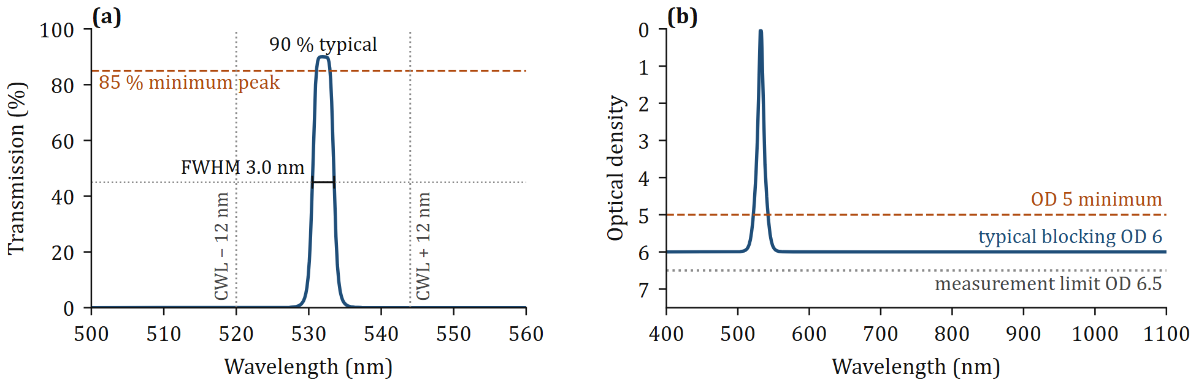
Figure 1. Typical transmission of NB-532-3-B, AOI 0°, 23 °C, unpolarized. (a) Passband on a linear scale, 500 to 560 nm. (b) Blocking as optical density, 400 to 1100 nm. Typical curve from the passband model of the NB series (three-cavity shape, FWHM 3.0 nm, peak 90 %, blocking floor OD 6); it is not a measurement of one filter.
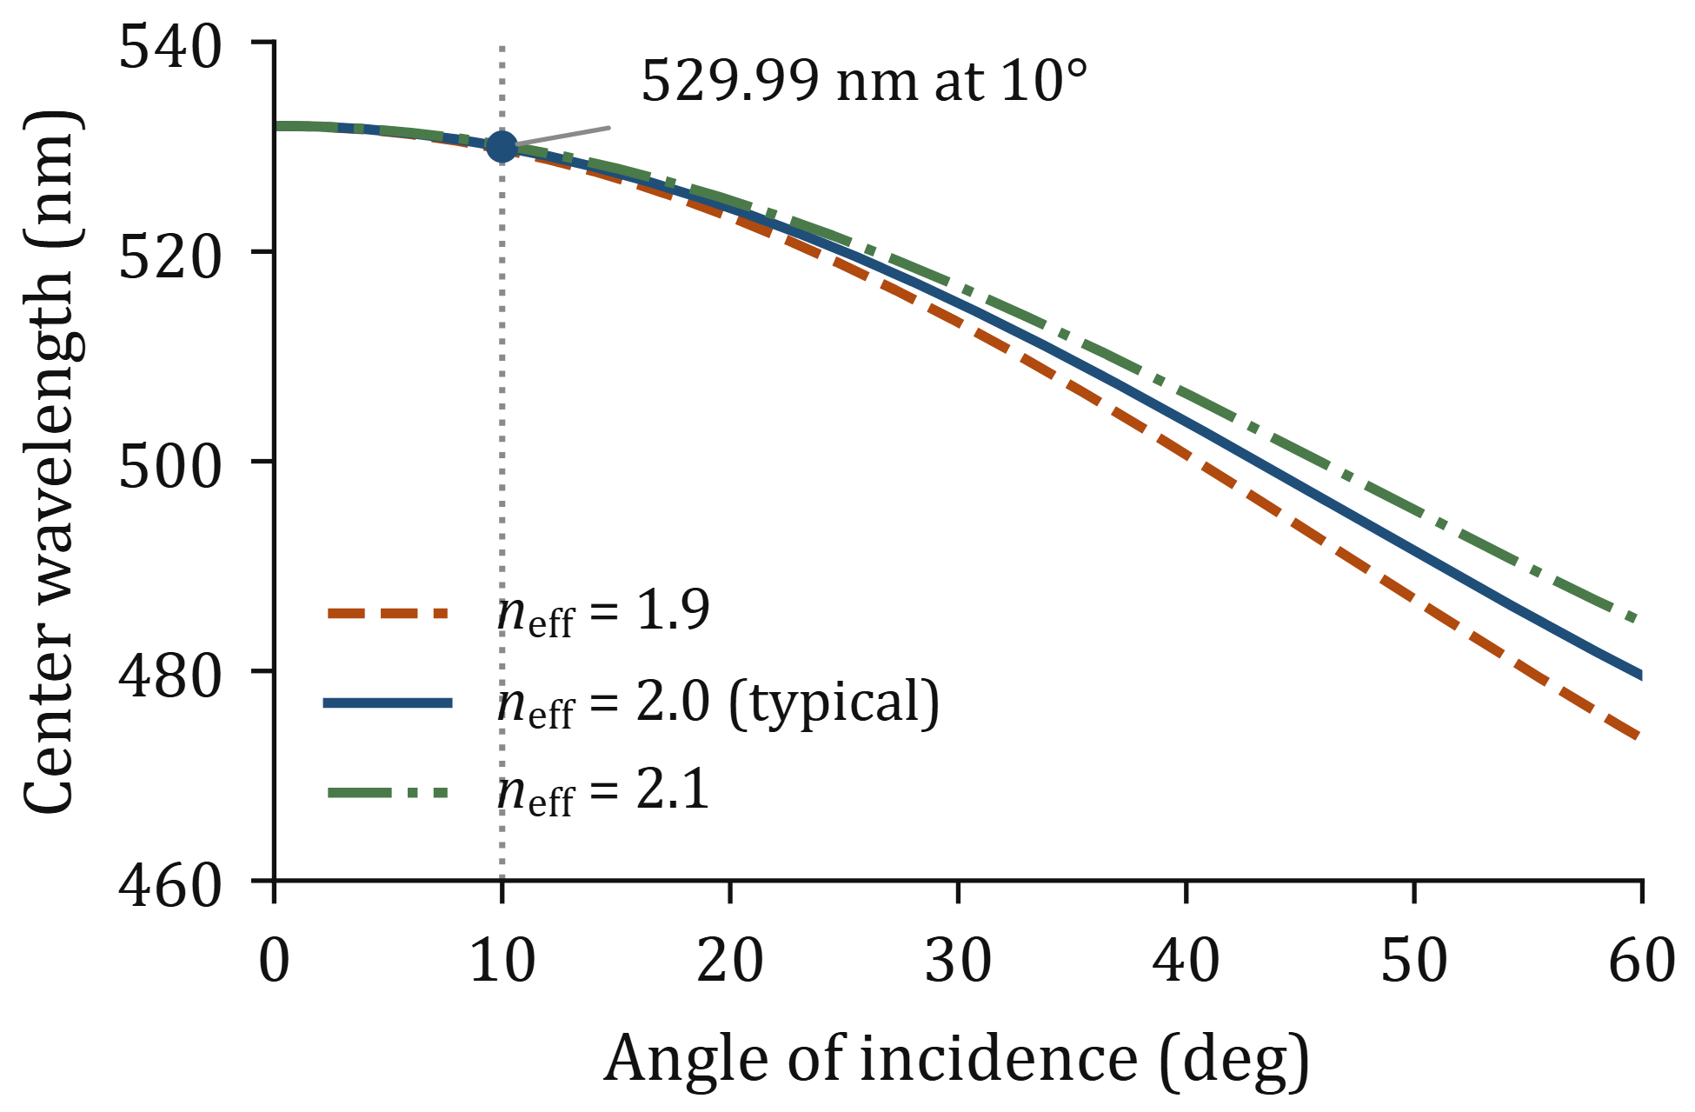
Figure 2. Center wavelength against angle of incidence in air, unpolarized, from Eq. (1) with n_{eff} of 1.9, 2.0 and 2.1. The dotted line marks 10°.
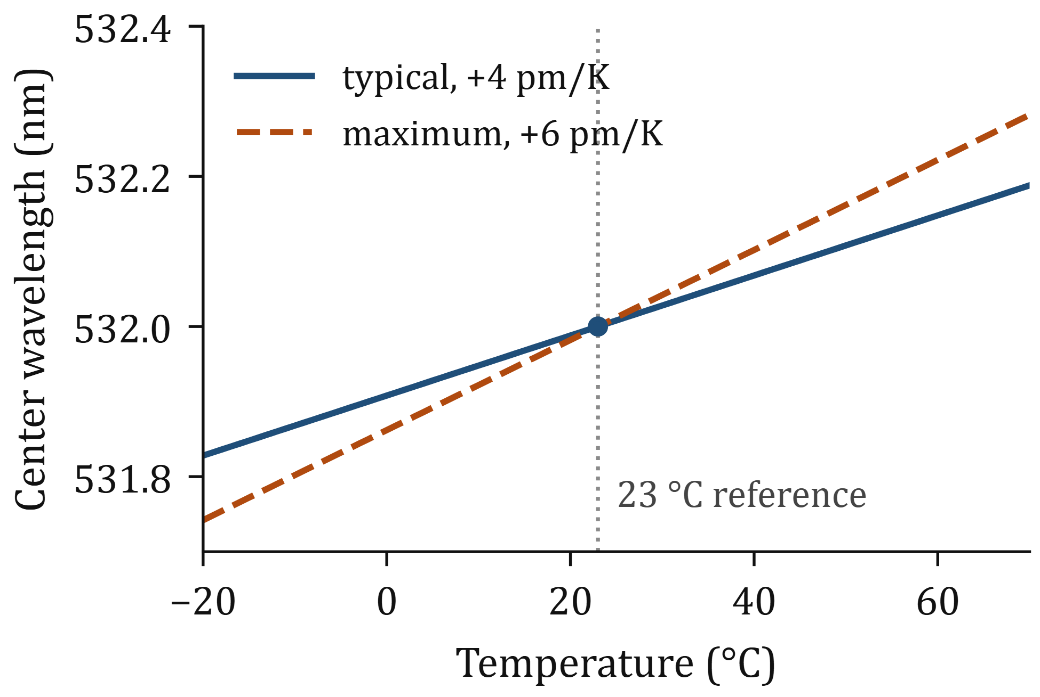
Figure 3. Center wavelength against temperature, AOI 0°, typical coefficient (+4 pm/K) and maximum (+6 pm/K), both through 532.0 nm at 23 °C.

Using the filter at an angle
Tilting moves the passband to shorter wavelengths. In air, with n_{eff} from Table 3,
 | $λ(θ)=λ_{0}\sqrt{1−{\left(\frac{sinθ}{n_{\text{eff}}}\right)}^{2}}$ | (1)
For n_{eff} = 2.0 the center wavelength is 529.99 nm at 10°, a shift of −2.01 nm, or 67 % of the bandwidth. The shift is −0.51 nm at 5°, −7.84 nm at 20° and −34.36 nm at 45°. At 10° it is −2.23 nm for n_{eff} = 1.9 and −1.82 nm for 2.1.
Tilt tuning. Tilt only lowers the center wavelength. A filter that measures 533.0 nm at AOI 0° reaches 532.0 nm at 7.0° (6.7° to 7.4° for n_{eff} from 1.9 to 2.1). A filter at the 531.0 nm lower limit cannot be tuned up to 532 nm.
Converging and diverging beams. Each ray sees its own angle. In an f/2 beam (half angle 14.04°) the pupil-averaged shift is −2.00 nm at normal incidence and −3.93 nm at 10° tilt, and the passband broadens. Use the filter in collimated space where bandwidth matters. The calculator at jezdangomez.com/calculators/aoi-shift covers other beams.

Mechanical
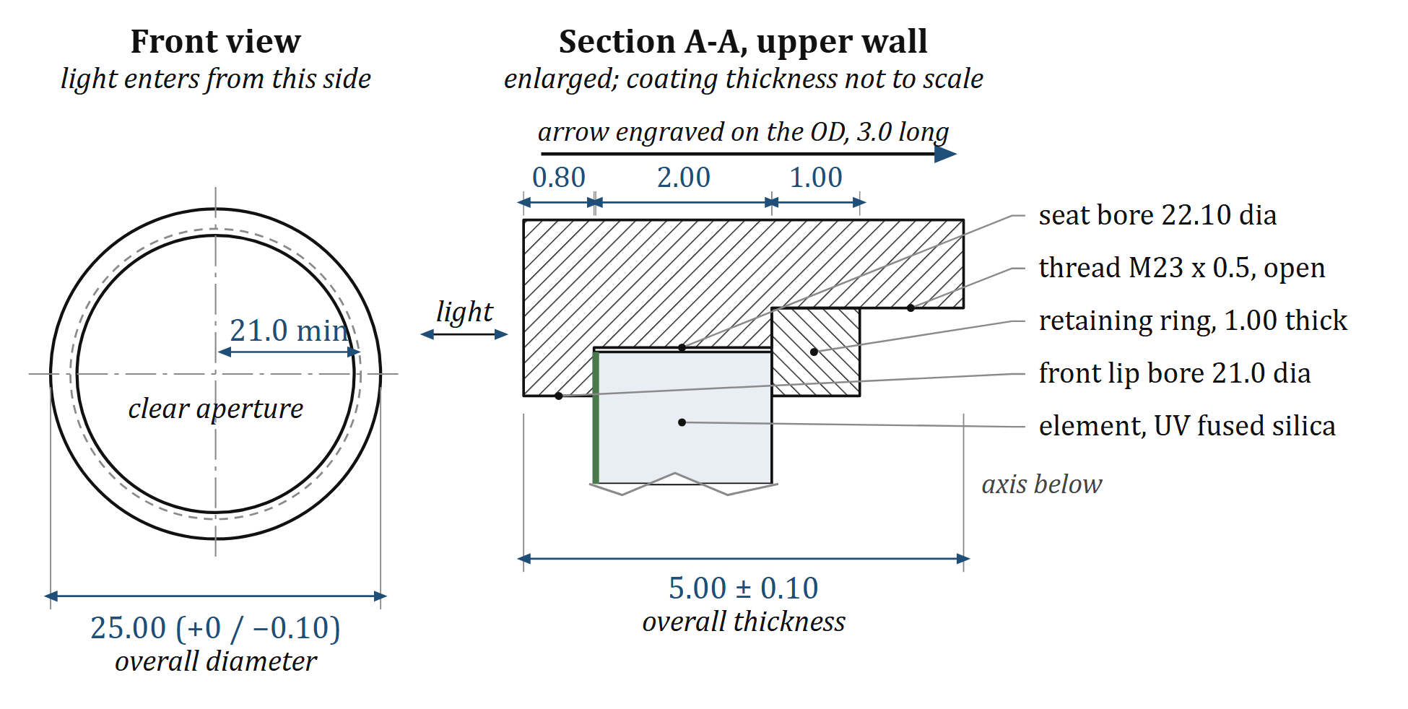
Figure 4. Outline of NB-532-3-B (size B), dimensions in mm. Front view with the element shown dashed, and section A-A through the upper wall at a larger scale. The formal drawing is NB-25-B-OD-001, Rev A.
Table 4. Mechanical and material characteristics of NB-532-3-B
Parameter | Value | Tolerance or limit | Unit
Mounted outside diameter | 25.0 | +0 / −0.1 | mm
Mounted thickness | 5.0 | ±0.1 | mm
Clear aperture, diameter | 21.0 | min | mm
Substrate, UV fused silica, dia × thick | 22.0 × 2.0 | reference | mm
Transmitted wavefront, 633 nm, over the clear aperture | λ/4 | max
Wedge | 3 | max | arcmin
Surface quality | 60-40 | scratch-dig
Coating and mount | ion-beam-sputtered Nb₂O₅ / SiO₂ multilayer on one substrate; black anodized aluminum ring, arrow engraved

Handling and mounting
- The arrow engraved on the ring points in the direction of transmission. The coated face, on the lip side of the ring, faces the light source.
- Clamp on the ring only; do not load the element. Maximum retaining ring torque 0.15 N·m.
- Handle by the ring. Blow off dust with dry nitrogen; clean with spectroscopic-grade alcohol on lens tissue; no ultrasonic bath. Store dry between −40 and +85 °C.

Revision history
Rev A, 2026-06-12. Initial release: four values and one curve.
Rev B, 2026-10-24. Test conditions added to every specification; typical values separated from limits; blocking stated outside CWL ± 12 nm; three curves drawn from code; tolerance notes, test policy, part number key, outline and handling notes added.
Sespe Optics is a fictional company. Portfolio sample by Jezdan Gomez, jezdangomez.com.

